Hot Wallet
# Source: AI Source: Provided by: [Data Path: Persons Table -> ID Column: 1, Name_En Column: Motasem Essam] -> From: [ChatGPT] on [1/21/2026]
A Hot Wallet is a cryptocurrency wallet that is connected to the internet, making it convenient for daily use, trading, and fast transactions. It stores private keys digitally and allows users to send and receive crypto assets instantly.

🔥 Key Characteristics of Hot Wallets:
# Source: AI Source: Provided by: [Data Path: Persons Table -> ID Column: 1, Name_En Column: Motasem Essam] -> From: [ChatGPT] on [1/21/2026]
- Internet-Connected
  - Always online and ready for transactions.
  - Accessible via web browsers, mobile apps, or desktop apps.
- Fast and Convenient
  - Ideal for frequent trading or small payments.
  - Supports instant sending and receiving of crypto.
- Private Keys Stored Digitally
  - In software or browser storage (custodial or non-custodial).
  - Some wallets give full control to the user (non-custodial); others hold the keys for you (custodial).

📱 Examples of Hot Wallets:
# Source: AI Source: Provided by: [Data Path: Persons Table -> ID Column: 1, Name_En Column: Motasem Essam] -> From: [ChatGPT] on [1/21/2026]
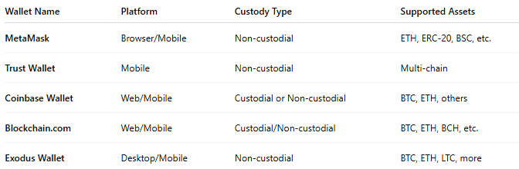

Wallet Name | Platform | Custody Type | Supported Assets
MetaMask | Browser/Mobile | Non-custodial | ETH, ERC-20, BSC, etc.
Trust Wallet | Mobile | Non-custodial | Multi-chain
Coinbase Wallet | Web/Mobile | Custodial or Non-custodial | BTC, ETH, others
Blockchain.com | Web/Mobile | Custodial/Non-custodial | BTC, ETH, BCH, etc.
Exodus Wallet | Desktop/Mobile | Non-custodial | BTC, ETH, LTC, more

✅ Advantages:
# Source: AI Source: Provided by: [Data Path: Persons Table -> ID Column: 1, Name_En Column: Motasem Essam] -> From: [ChatGPT] on [1/21/2026]
- Easy to use and quick to access
- Great for daily transactions and trading
- Often includes integration with DApps, DeFi, and NFTs
- Supports QR code scanning, token swapping, and browser extensions

⚠️ Disadvantages:
# Source: AI Source: Provided by: [Data Path: Persons Table -> ID Column: 1, Name_En Column: Motasem Essam] -> From: [ChatGPT] on [1/21/2026]
- Higher risk of hacking or malware due to internet exposure
- Requires strong security hygiene (passwords, 2FA, backups)
- Not ideal for long-term storage of large crypto amounts

🧠 Best Use Cases:
# Source: AI Source: Provided by: [Data Path: Persons Table -> ID Column: 1, Name_En Column: Motasem Essam] -> From: [ChatGPT] on [1/21/2026]
- Active traders
- Small, everyday crypto payments
- DeFi users & NFT collectors
- Beginner users who want convenience

🔐 Security Tips for Hot Wallets:
# Source: AI Source: Provided by: [Data Path: Persons Table -> ID Column: 1, Name_En Column: Motasem Essam] -> From: [ChatGPT] on [1/21/2026]
- Use strong passwords + 2FA
- Never share your seed phrase/private key
- Backup your wallet and store the backup securely
- Avoid using hot wallets on public or shared devices
- For large holdings, transfer to cold storage (hardware wallet)

🆚 Hot Wallet vs Cold Wallet
# Source: AI Source: Provided by: [Data Path: Persons Table -> ID Column: 1, Name_En Column: Motasem Essam] -> From: [ChatGPT] on [1/21/2026]
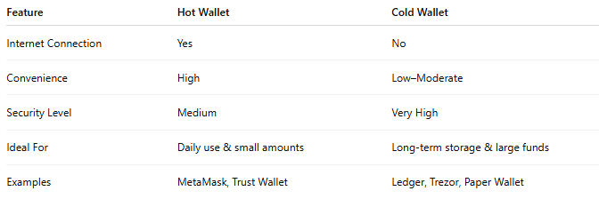

Feature | Hot Wallet | Cold Wallet
Internet Connection | Yes | No
Convenience | High | Low–Moderate
Security Level | Medium | Very High
Ideal For | Daily use & small amounts | Long-term storage & large funds
Examples | MetaMask, Trust Wallet | Ledger, Trezor, Paper Wallet

